**Brand Guidelines**

**Synopsis**

The sharing economy is one of the fastest growing business trends in history, primarily driven by cost savings and growing environmental consciousness of consumers. We are seeing a growing opportunity for providing an easy and environmentally friendly way to replace old wants and needs with new ones, without spending money.

The company aims to build the world’s most user-friendly online marketplace for swapping goods and services. Our goal is to make swapping between users as easy, fast and convenient as it is to buy and sell items on Facebook Marketplace.

Our product is a web app (& phone browser compatible) designed to connect people who want to swap their goods and services. There is no money being exchanged on the platform, same as facebook marketplace. Users will go on the website, list items they want to get rid of and quickly find items or services to swap with. Users arrange the transaction between themselves through our messaging feature.

**Our Mission**

We believe that if there were an easy, convenient, fast and free way to swap second-hand goods and services, it would be widely adopted and impact the way many people take part in the sharing economy. Would be great for the environment and great for wallets. It’s our mission to make this reality.

**Our Vision**

Our vision is to become the “Facebook Marketplace for bartering”. For every item or skill that you own and don’t see value in, there are thousands of others who do and own something you value. We aim to become the go-to platform for matching the millions of people in this position.

**How are we different?**

1. For a swap to occur, both users must want what the other has to offer. Simply relying on the “double coincidence of wants” significantly limits the volume of swaps for our competitors. We will use advanced AI and filtering tools to display the right listings in front of the right users in order to facilitate and maximize matches.
2. Consumers will only swap goods and services if it is extremely easy and convenient to do so. Current solutions involve a very complex, ugly and time consuming user experience that puts people off. Our UX / UI will optimize to make it easy & convenient, in as few steps as possible.

**Our values**

We are all about Easy, Trusting and Familiar.

**Easy**

We really value ease of use for our customers. In everything we develop, we strive to have them say “wow, that was easy”. This is critical to get users to stick over time and encourage word of mouth. We aim to achieve this by creating a very clear path for the user to follow, in as few steps as possible and in as few words as possible. Colour contrasts are clear and easy on the eye.

**Trusting**

An important value we want to convey is trust. We must make users feel safe and minimize their natural fear which is encountering scammers or making bad trades. We must therefore achieve a professional and trustworthy feel through the product’s consistency, colours, typography and minimalist design style.

**Familiar**

While an online marketplace tailored to optimize swaps has never been seen before, we care about creating a familiar environment so that user do not put much effort into learning or thinking.

**Our Logo**

**V1 Logo (subject to change)**

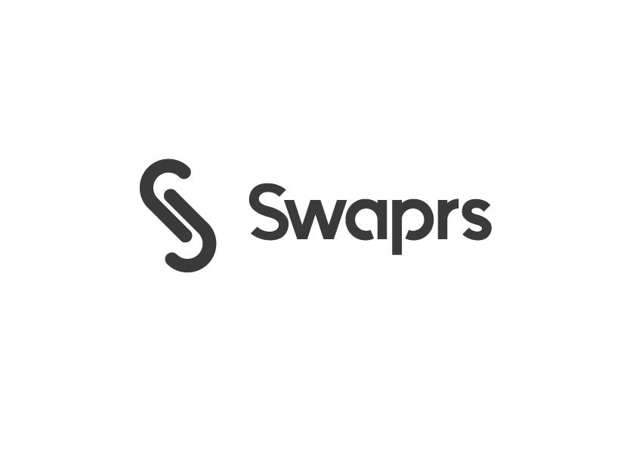

* We will soon send over a folder of final logo version with all sizes/backgrounds etc.
* Swaprs is pronounced “swappers”
* Only the first letter is spelled with a capital letter

**Primary Colour Palette**

Will have to test different colours and probably add another primary colour like orange.

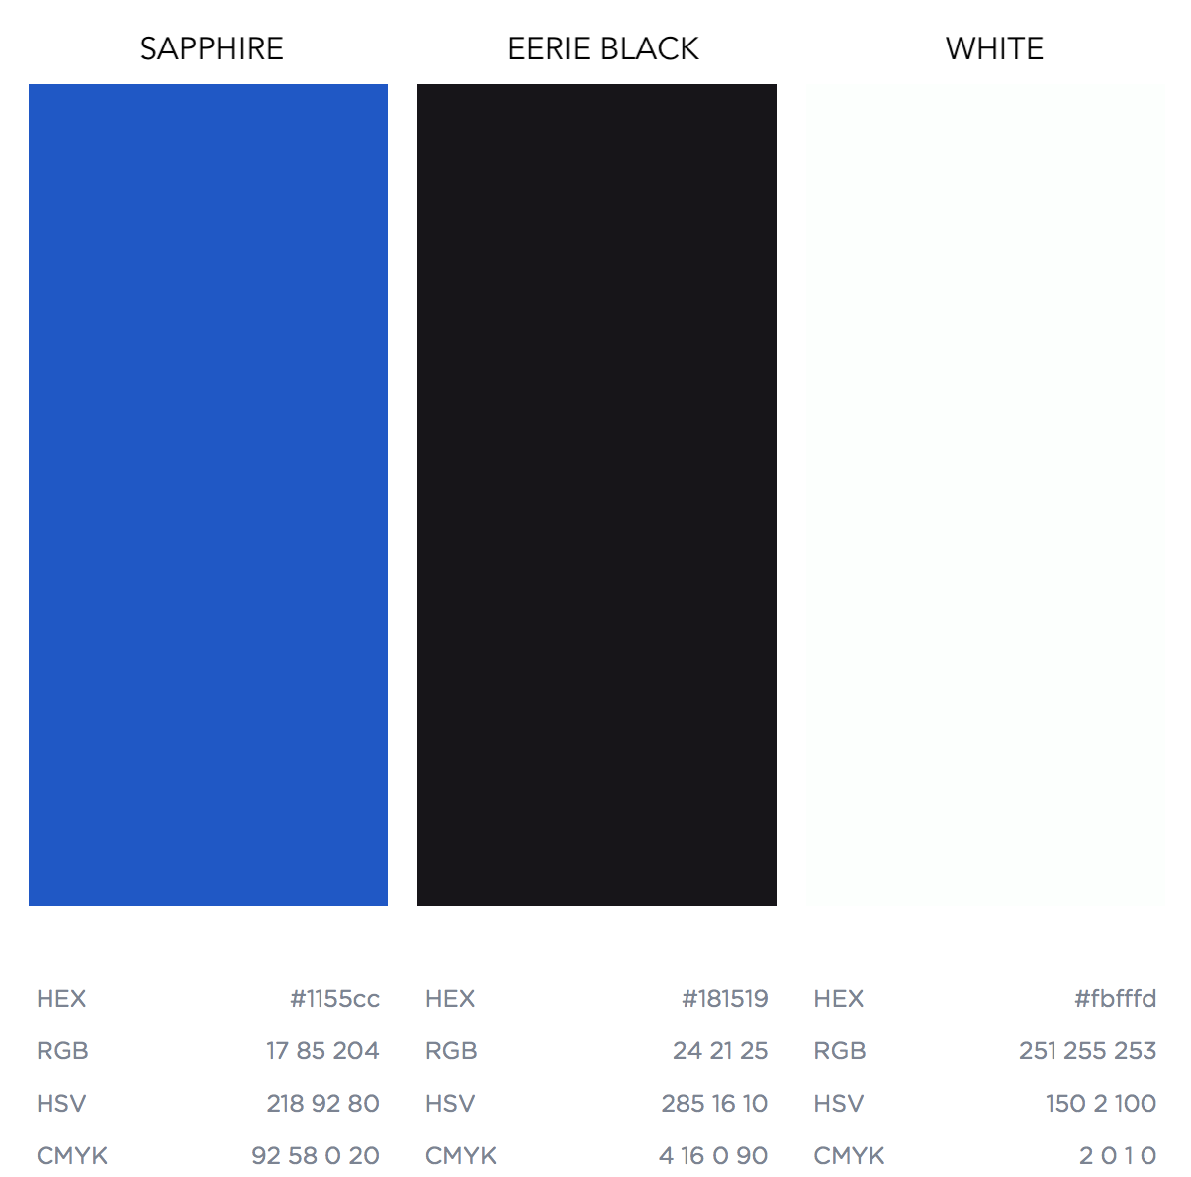

**Typography**

|  |  |  |
| --- | --- | --- |
| Montserrat Extra Bold | 48 | Heading One |
| Montserrat Extra Bold | 36 | Heading Two |
| Montserrat Extra Bold | 24 | Heading Three |
| Montserrat Extra Bold | 18 | Heading Four |
| Montserrat Extra Light | 12 | Text One |

**Websites we like and why**

**Mercury -** <https://mercury.co/>

* Our favourite UI (minimalist, simple, beautiful)
* Very quick and clear onboarding process

**Subito -** [www.subito.it/](https://www.subito.it/annunci-italia/vendita/usato/?from=box-marketplace)

* Practical and consistent UX
* Clear colour coding, easy on the eye
* Very good ad positioning

**Facebook Marketplace**

* Very easy and quick UX.
* We should test what they do with ads positioned between the listings